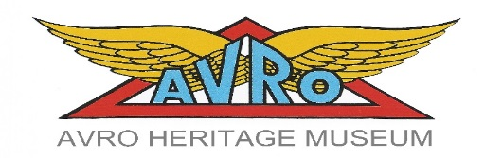

Avro Heritage Museum Educational Trips & Visits for Schools and Voluntary Organisations

Planning and booking your visit: Frequently asked questions

When are we open?

Museum Opening Times:
From March to November the Museum opening times are:
Monday: Closed (Except Bank Holidays)
Tuesday: Members and Group/Schools and group Visits
Wednesday: Closed
Thursday: Members and Group/Schools and group Visits
Friday: 10.00 to 17.00 (Last Admission 16.30)
Saturday: 10.00 to 17.00 (Last Admission 16.30)
Sunday: 10.00 to 17.00 (Last Admission 16.30)
Group and Schools and group Visits are normally scheduled on Tuesday or Thursday; Tuesday, Thursday and Friday evenings are available during British Summer Time (BST) from 6:00 pm to 8:00 pm. Other days may be available by arrangement
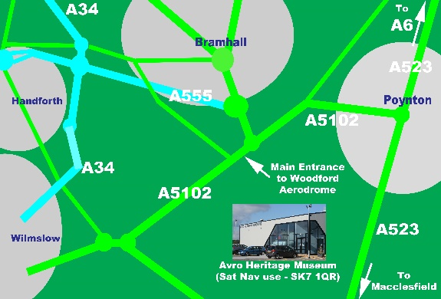
Where are we?

Avro Heritage Museum,
Woodford Aerodrome,
Chester Road, Woodford,
Stockport, Cheshire, SK7 1AG (Use SK7 1QR with GPS Navigators)
How can I find out more about the education programme?
For more information about current exhibits and tours please contact the Museum (Educational Trips & Visits Programme) to make a group booking:
Mike Orme or Roger Yates: Telephone: 01625 877534

Also Find Us On:
Web: http://avroheritagemuseum.co.uk/
Facebook: facebook.com/avroheritagemuseum
Free Wi-Fi is available in the Museum
Telephone: 01625 877534
Email: avroheritage@gmail.com
Web: http://avroheritagemuseum.co.uk/
FAQ

Do I need to book for a schools and group visit?
Booking is essential, even for self-conducted visits. Groups who have not booked may be turned away if the Museum is busy with previously booked in groups.

Is there a maximum group size?
Within reason we can accommodate most large groups. We ask that large groups divide in to smaller groups (maximum of 10) to move around the Museum and that there is a responsible adult with each group. Group leaders are responsible for their students at all times.

How many adults do I need to bring?
If you are bringing groups of students under the age of 16 we ask for a minimum of 1 adult to 10 students. For younger children (under 10) we suggest a ratio of 1 to 6.

Is there a charge for schools and group visits?
Yes; for their education sessions for schools and groups. Accompanying adults have free admission in the ratio of 1/6 or 1/10 depending on the age of the group. The income realised through schools and group charges helps sustain the Museum’s schools and groups’ service. For more information and current charges please contact the museum:
What do we need to do before our visit? To ensure you have a safe and enjoyable visit we recommend you conduct a preliminary visit to familiarise yourself with the layout of the Museum and create your own risk assessment. We have a AHM risk assessment to help plan your own. You can arrange to meet a member of our visits and learning team to help plan your visit and to discuss any aspects of your session.

How can the Museum support children with additional needs?

We want to provide all members of your group with an enjoyable and inclusive visit. It would therefore be helpful if you could inform us prior to your visit if there are adults or children with additional needs within your group. If you have any adults supporting children on a 1:1 basis they should be in addition to the minimum number of required adults. If you have any queries or questions please do not hesitate to contact our Bookings Coordinator.
Is the Avro Heritage Museum accessible for wheelchair users?
The Avro Heritage Museum is accessible for wheelchair users. There is lift access to all floors. Disabled and gender neutral toilets are fully accessible.

Have the Avro Heritage Museum Education Staff DBS (Disclosure & Barring Service) Checks?
Yes. All lead education staff have current DBS Checks
Arriving at the Museum

Is there a coach drop off point?
Yes: they have their own designated parking space. Please be aware that coaches using the entrance to the site do so at their own risk. This is not a public highway.

Is there any parking at the museum nearby?
The Museum does have a car park. There are also some designated parking for disabled visitors adjacent to the Museum entrance.

Where do we go when we arrive with our group?
This will vary depending on your group and what you are coming to do. Most schools and group groups will use the main entrance but please check your booking confirmation letter carefully for instructions. We kindly request that groups do not arrive any earlier than 10 minutes before they are booked in.

Facilities at the Museum

Where can we leave coats and bags?
Schools and group bags, coats and lunch boxes may be left in The Lancaster Room

Do you have anywhere to eat packed lunches?
Our cafe can be booked for groups to eat packed lunches or snacks. The cafe can take a maximum of 30 students.

Can schools and group groups visit the shop?
Groups are very welcome to visit the Avro shop. Large groups are asked to divide in to smaller groups to visit the shop. Group leaders are responsible for their children, pupils or students in the shop.

Museum dos and don’ts

Are there Museum rules?
The group leader is responsible for the behaviour and conduct of their group when they are in the museum. We have a Code of Conduct that we ask all groups to read and abide by. This can be found on the website:

Can we eat and drink in the galleries?
Eating and drinking is not allowed in the galleries.

Can we smoke on the Museum site?
The Avro heritage Museum is a no smoking site. This includes the forecourt outside the Museum and the outside seating areas to the rear. This also includes Electronic Cigarettes.

Can we wear backpacks in the Museum?
Backpacks should not be worn on children’s backs because of the danger to objects. They can be carried in the hand or left the Lancaster Room

Can we carry umbrellas in the Museum?
No. Large umbrellas (that can’t fit in your bag) must be left at the Museum entrance.
They aren’t allowed to be carried in the galleries because of the possible damage they may cause to objects on open display.

Can we take photographs in the galleries?
Photography is permitted except where otherwise indicated. If in doubt please ask a
Member of gallery staff, they will be happy to help. Please respect other people in the galleries when you are taking photographs

Can we draw and record information in the galleries?
People are very welcome to draw in the Museum. Most dry art materials can be used e.g. pencils, ballpoint pens, felt pens, coloured pencils, drawing boards, pencil sharpeners (with pots to catch the bits) erasers, as well as sellotape, staplers and dry collage materials. To protect the objects and the galleries paints and open ink wells are not allowed in the galleries. If in doubt please check with gallery staff

Further guidance to youth groups proposing to visit the museum

- The group leader/Officer/Akela/Brown Owl; MUST accompany the pack. It is NOT acceptable to just rely on parents or friends to drop off/pick up and supervise the visit.
- It is important to let AHM know the final numbers of both adults and group numbers at least seven days prior to the visit
- Complimentary entrance is in the ratio of 1/6 for children under 10 and 1/10 for children under 16. Other adults/leaders/parents will be charged at the normal adult rate. This however may be negotiated depending on the make-up of the visiting group. Group leaders have free admission; however parents who wish to accompany their children and undertake the museum tour will be charged at the normal adult rate.
- It is the responsibility of the Group Leader to ensure that children who are dropped off by parents are picked up on time by an appropriate or designated parent, carer or guardian
- Please do consider the focus of the visit and discuss this with a tour guide. In general allow 1 to 2 hours for the visit depending on the focus

RY/MB (For and on behalf of the Trustees) – January 2020

